**Chapter 2 Exercise Questions**

Name: Victor Marrujo

1. **Write a Boolean equation in sum-of-products canonical form for the following truth table (5 pts.):**

|  |  |  |  |  |  |  |  |  |  |
| --- | --- | --- | --- | --- | --- | --- | --- | --- | --- |
|  | |  | | --- | |  | | A’B’C | | A’BC’ | | A’BC | | AB’C’ | | **AB’C -1Y is 0 should not be included** | | ABC’ | |  | |

**Y= A’B’C + A’BC’ + A’BC + AB’C’ + ~~AB’C~~ +ABC’**

1. **Minimize the following SOP Boolean equation using Boolean Algebra:**

**Y = A’B’C + ABC’ + ABC**

**Make sure and show what theorems are being used (5 pts.).**

Apply T8 to ABC’ + ABC -> Y = A’B’C + AB( C + C’ )

Apply T5’ to C + C’ -> Y = A’B’C + AB(1)

Apply T1 to A (1) -> **Y = A’B’C + AB**

**3. Populate the K-map using the following truth table (.5 pt. for each correct square or 4 pts. total):**

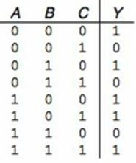

**BC**

**A**

**00**

**01**

**11**

**10**

**0**

1

1

**1**

1

1

1

1. **Populate the K-map using the following truth table (.5 pt. for each correct square or 8 pts. total).**

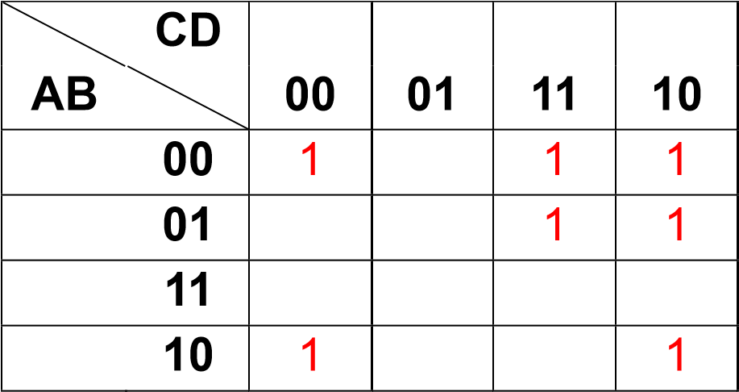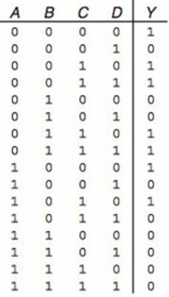

1. **Group the 1’s in the following K-map. Use a different font color for each group (5 pts.).**

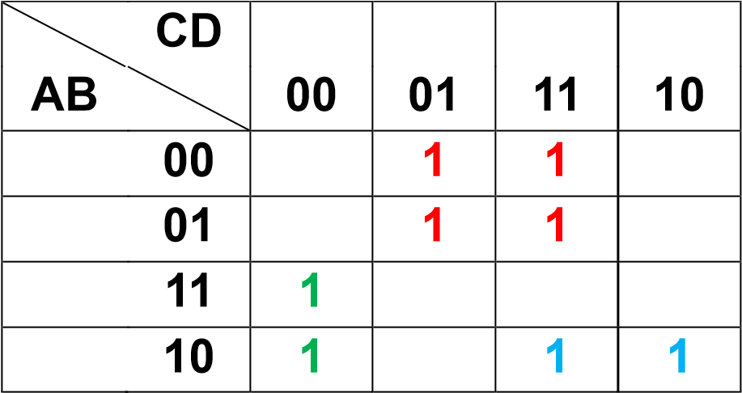

1. **Determine the product terms for the following Kmap groups with an output of Q. Make sure and explain the reasoning for each term (5 pts.):**

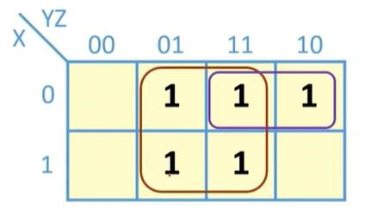

Red Product Term: **X and X change so they can be eliminated. Z is 1 the product term is Z.**

Purple Product Term: **Z changes so it can be eliminated. Y is 1 the product term is Y. -1 incorrect, Z changes, so Z can be eliminated, X and Y do not change. X is 0 and Y is 1, so the term would be X’Y**

Final Equation: **Q = Z + ~~Y~~** X’Y

1. **Determine the product terms for the following Kmap groups with an output of Q. Make sure and explain the reasoning for each term. Each group is defined using a different font color (5 pts.):**

**BC**

**A**

**00**

**01**

**11**

**10**

**0**

**1**

**1**

**1**

**1**

Blue Product Term: C is 1, A is 0, B is 0, so the product term is A’B’C

Red Product Term: C changes so it can be eliminated. A IS 1 AND B IS 1, so the product term is AB.

Final Equation: **A’B’C + AB**

1. Determine the propagation delay and contamination of the following circuit using the gate delays in the following table. Make sure to show your work (3 pts):

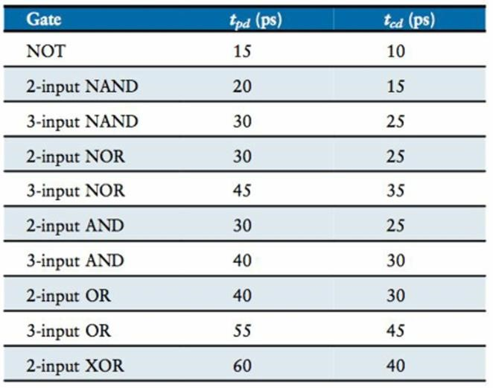

**Propagation delay**

**:**

(2

4

-

input

NAND * 20) = 80

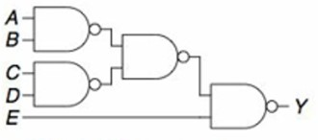

**-1.5 You did not specify the critical path, which is what you use to calculate the propagation delay.**

**Propagation Delay = 3 2-input NAND gates * 20 = 60. It is not the sum of all the gates.**

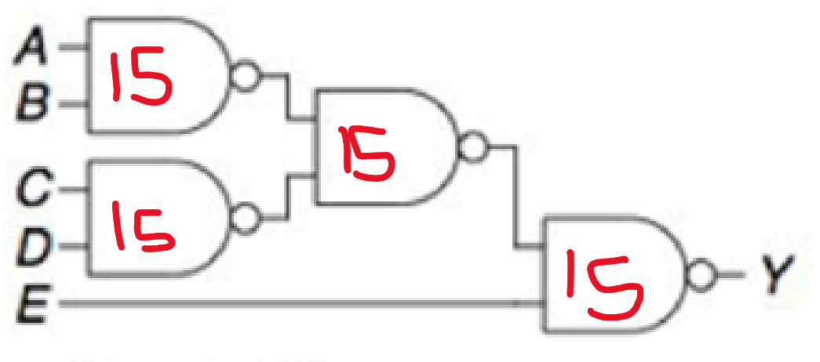

**Contamination :**

4 (2-input NAND * 15) = 60

**-1.5 You did not specify the shortest path, which is what you use to calculate the contamination delay.**

**Contamination = 1 2-input NAND gates * 15 = 15**